One Paved Court – Workshop – Learn how to make an artist’s book

Sat 20th April, 2.00pm
2.5hrs
£25.00

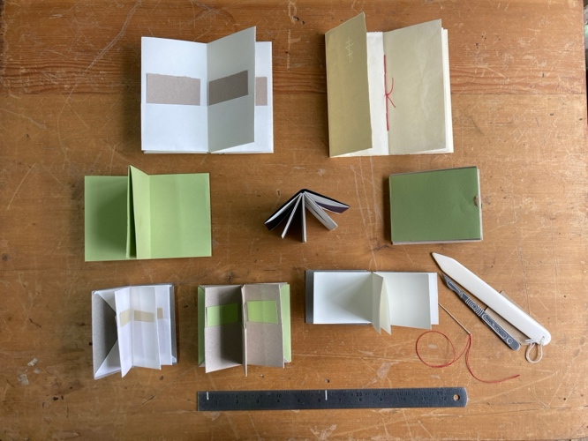

Learn how to make an artist‘s book
Learn how to make a concertina book, plain or with pockets
Create this book to hold your drawings, thoughts, feelings about a personal object

Bring along a small object, or something from nature, that has meaning for you
Or use one of the objects in the exhibition

In this short session we will look at the objects brought in and the stories they might tell. We will then go on to look at a few artists’ books and discuss how best to tell your story.
You may wish to make a paper pricking to describe your object or a blind drawing (a quick drawing made without looking at the paper); you may wish to add text in the form of handwriting or words sourced from found books.

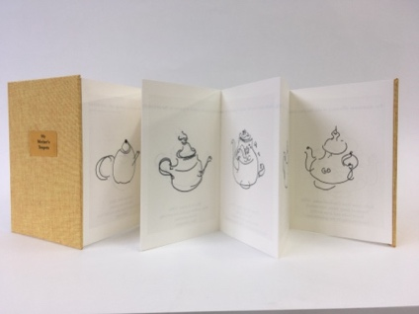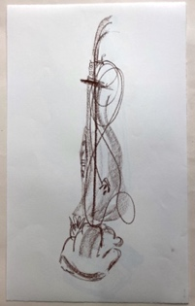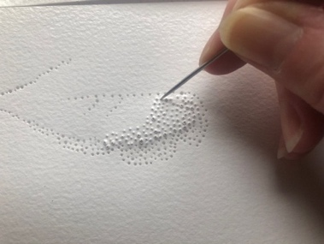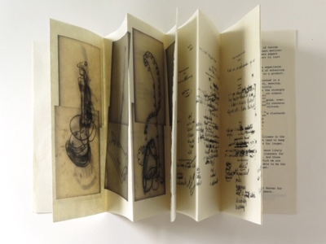

Book through the website for One Paved Court or Eventbrite

